BUILDING UP STEAM: GLASGOW CITY COUNCIL’S PARTICIPATORY BUDGETING JOURNEY

By Dr Rosie Ilett and Evelyn O’Donnell

Introduction

Participatory Budgeting is becoming embedded in the practice of national and local government, and reaching wider public awareness, as we move towards 2021 when at least 1% of all council budgets in Scotland will be determined by local communities. Local authorities, including Glasgow City Council that will be focused on here, are building their experience in allocating funds to local neighbourhoods via the PB process.

Glasgow’s PB track record

Prior to the work in four Glasgow City Council Wards described below, Glasgow Community Planning Partnership (CPP) undertook a PB process in 2016 that provided useful learning. Twenty-one engagement events were held in April 2016 to allocate £10,000 of Partnership Budget funding in each area. The events attracted over 1,000 local people who worked with CPP partners to decide, via a voting process, which agencies should receive funding. One hundred and nineteen organisations were chosen - work with young people attracted 36% of the funding, and £209,572 was allocated overall - often to small, grassroots projects. For example, The ARC (After Recovery Community Project) received £2,960 from Partick West Area Partnership to work with people recovering from alcohol and drug addiction, and St Matthews Men’s Health Group in Possilpark was awarded £624 to provide social support to men living in isolation.

Although this experience had positive outcomes and tested out the viability of PB in Glasgow, key issues emerged. Despite publicity and Council support, the number of local people and organisations involved were relatively modest. Although many funded agencies proposed work with hard to reach populations, and 17% had never previously applied for such funding before, established organisations tended to get more votes at community meetings, perhaps sidelining new ideas about how best to address local issues.

PB moving on across Glasgow in 2018

Learning from the 2016 work, in 2018 Glasgow City Council launched a new strategy to give £1m to four areas of the city and to a community of interest (via Glasgow Disability Alliance) to test out PB further, with a Council-led PB working group overseeing the work in partnership with third sector and national PB organisations. As the Council’s overarching aim for PB is to reduce poverty and inequality, the four Wards chosen were some of the most deprived in Glasgow, with priorities for funding and community engagement reflecting local need. In addition, a community of interest with the Glasgow Disability Alliance will be funded to support people with disabilities to get involved in development and delivery of the PB process.
Calton (Ward 9, covering Bridgeton, Dalmarnock, Calton, Camlachie, Gallowgate and Parkhead) would therefore focus on child poverty; Canal (Ward 16, that includes Cadder, Hamiltonhill, Lambhill, Milton, Parkhouse, Possilpark, Ruchill) on work and employment; Pollokshields (Ward 6, comprising Craigton, Dumbreck, Pollokshields, Shawlands and Strathbungo) to address issues of black and minority ethnic population experience, and Pollok (Ward 3) to support work for, and engage with, young people in the Ward areas of Crookston, Darnley, Deaconsbank, Househillwood, Nitshill, Priesthill, and Southpark Village.
To provide additional local capacity, GCC contracted third sector anchor organisations in the four wards in May and June 2018 to promote PB, and to identify and support local residents interested in joining Citizen’s Panels to help lead the process. They were also charged with ensuring that barriers to participation were reduced as much as possible through providing childcare, transport and other supports as needed. The North West Glasgow Voluntary Sector Network [NWGVSN) were given the role in Canal Ward; in Pollokshields it was Pollokshields Trust; in Pollok, local youth organisation SWAMP took on the brief, and in Calton Ward, two organisations – Child Poverty Action Group in Scotland (CPAG) for I whom I work, and Urban Fox (UF) – have been leading the work.

Five demonstrator projects – progress so far

With the time-scale to agree funding by March 31st 2019, PB demonstrator projects are working closely with GCC officials to deliver an inclusive, thorough process that will allocate funding to meet local need. All projects have used a variety of methods to reach into local communities, to raise interest in PB and its potential outcomes to individuals and to organisations who might wish to apply for funding, and to identify those residents willing to become further involved as part of the Citizen’s Panel that will shape the process. Local GCC councillors, MSPs and MPs are linked in in most of the areas, as are existing partnership initiatives like Children’s Neighbourhoods and Thriving Places.

- Glasgow Disability Alliance (GDA)

In December 2017, Glasgow Disability Alliance was successful in securing funding for “Building Capacity: GDA Voices for Change” from the Scottish Government to scope out how disabled people can play a full and meaningful role in Participatory Budgeting in Scotland. The Project ran January – June 2018 and the Report was launched by Cabinet Secretary for Communities and Local Government on 24th August 2018 at an event in Glasgow with over 300 disabled people and their supporters. Findings show that disabled people can become empowered and play their full part in the national roll out of Participatory Budgeting, if the right support is provided. GDA findings and recommendations outline how to reduce the inequalities disabled people face, ensure meaningful participation and improve life outcomes. In addition, the Report demonstrates that the inclusion of disabled people across Glasgow in PB can aid the success of National and Local Government PB programmes.

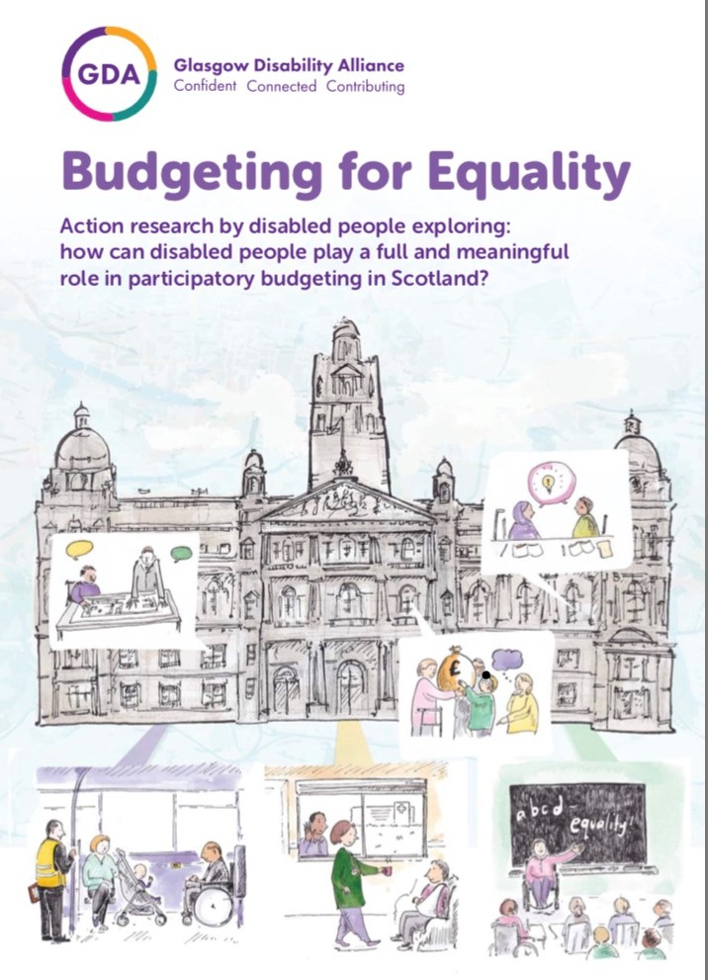
Moving forward, Phase 2 will fund “Budgeting for Equality: Disabled People & 2nd Generation PB” building on Phase 1 and levering in investment from Glasgow City Council to rollout recommendations of GDA’s Budgeting for Equality Report which can be found here: GDA Budgeting for Equality report

This will ensure that disabled people are involved in PB demonstration areas as well as in mainstream service provision and demonstrates a National and Local Government commitment to both PB and the inclusion of disabled people in the process of transformational community led budgeting.

b. Canal Ward 16

The NWGVSN created an overarching brand – 3C – standing for Community Choices Canal, and undertook community engagement in the summer, attending a wide range of gala days and local events, promoting interest in PB through activities, colourful banners, raffles and information. Partnership working with local organisations including Young People’s Futures and the Concrete Garden,
While Ng Homes has reached specific population groups including those with Chinese heritage, and working with staff from NHS Greater Glasgow and Clyde and those involved in previous PB Panels in the Ward has helped secure local buy-in. Holding a community meal in Lambhill Stables was a successful way for potential Panel members to meet informally, and despite bad weather, there was good attendance and important issues were raised including challenges for communities in getting access to information, the reality that not everyone is community minded and the view that PB is an excellent way to bring confidence back to the community.

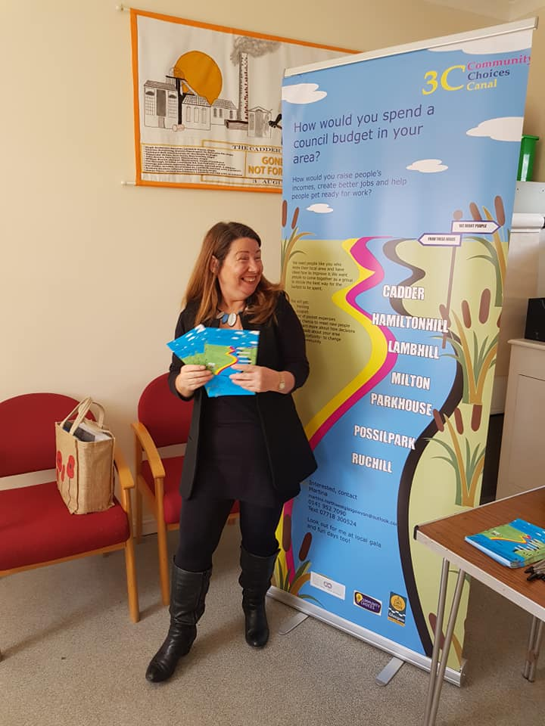

Follow Canal Ward 16 on Facebook and twitter at @3CCanalChoices

c. Calton Ward 9
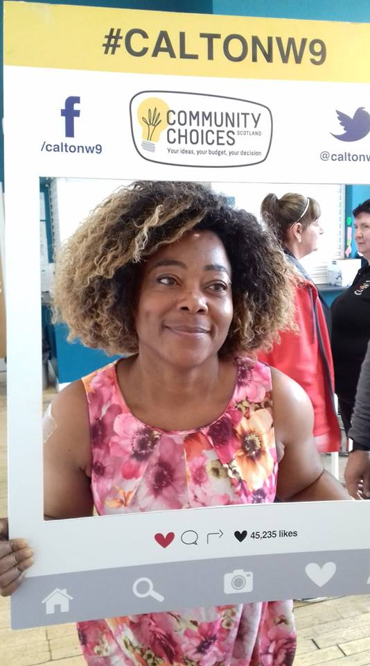
In the Calton Ward, CPAG and UF initiated a brand – Calton W9 – and made a ‘selfie frame’ decorated with PB messages and social media tags so portraits taken (with permission) at family fun days and community events over the summer could be publicised via social media. Over 50 people (including staff from Police Scotland, Strathclyde Fire and Rescue, colleges, schools and third sector organisations – as well as members of the public) put themselves in the frame. CPAG and UF also organized pop-up events at The Forge shopping centre in Parkhead with craft activities for children, and Parkhead Citizen’s Advice Bureau providing advice to passersby. Regular communications with organisations, social media, and disseminating 2,500 leaflets brought wide local awareness across the Calton Ward. The newly formed Calton Child Poverty Network of public agencies, community associations and third sector groups has also helped spread the word. Individuals interested in joining the Calton Panel were invited to information events to find out more about how the PB process would unfold, and to decide if they wanted to take part.

Follow Calton Ward 9 on Facebook @caltonw9 and on twitter @caltonw9choices

d. Pollok Ward 3

Over in Pollok Ward, the SWAMP Project has been working with young people, using a variety of media platforms including creating web-based TV programmes with young people to disseminate information about PB. They are currently supporting a group of young people who are interested in being part of the Citizen’s Panel and are scheduling workshops with Young Scot for online voting; All In for the Participatory Budgeting training, and Youth TV for communicating the PB process, applications and decisions.

Swamp are currently working with young people within the Greater Pollok ward to establish a citizen’s panel whilst also informing and promoting participatory budgeting to all young people within the ward. The young people have undertaken training in digital media and community engagement to support them in this role and will act as peer mentors for other young people within the community.

As PB moves forward the citizens panel will undertake further training in participatory budgeting and develop PBTV a digital platform that will be used to communicate the PB process to the young people of Greater Pollok including applications, voting and decisions. Young Scot will support this process through the development and delivery of an on-line voting system that will compliment PBTV.

The citizens panel will develop their social media presence and conduct consultations through visits to local schools, youth clubs and other organisations to further promote the PB process whilst also gathering information on what young people want and what’s currently available. This will help all young people within the Greater Pollok ward to evaluate current provision and make informed choices about what they want and what needs to be included or changed within their community.

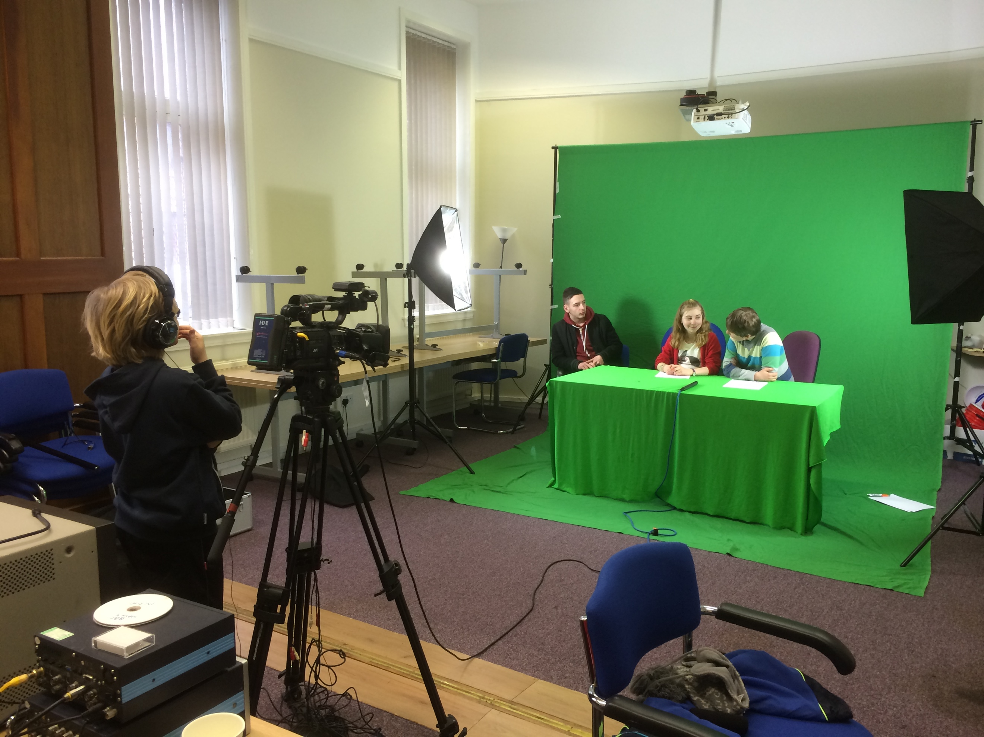
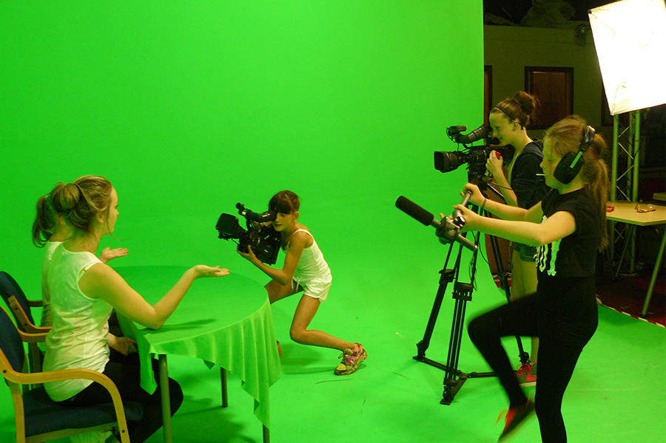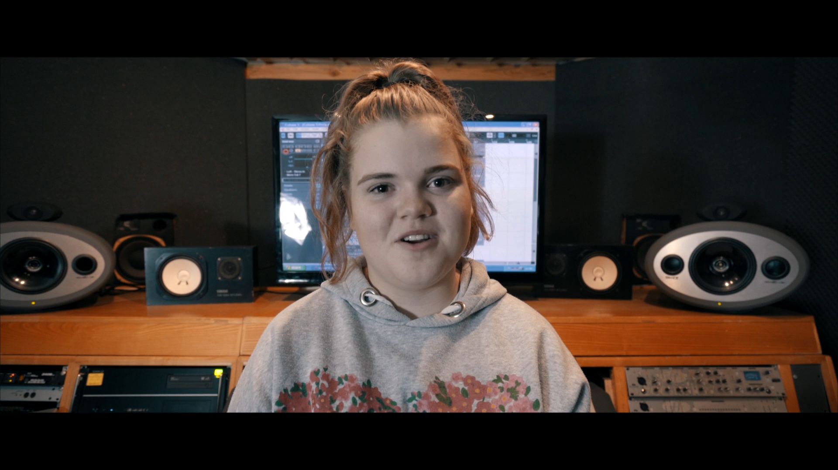

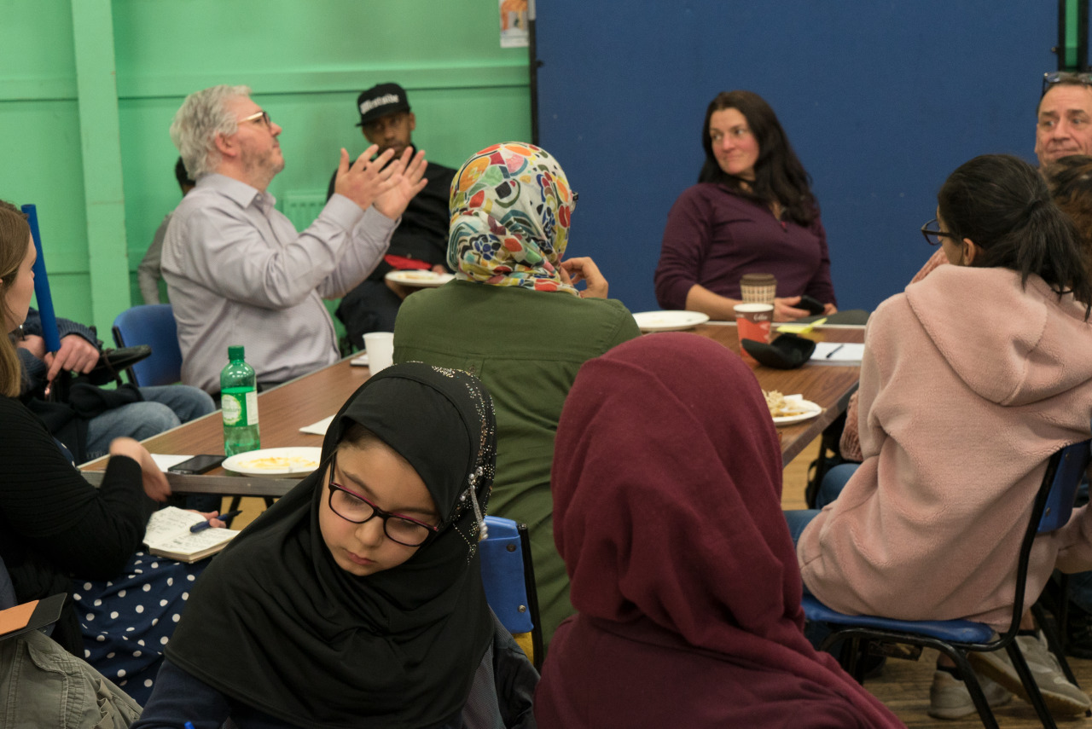
e. Pollokshields, Ward 6
Work in Pollokshields has focused on distributing leaflets and working with local agencies to hold a series of public meetings targeted at reaching the black and minority ethnic population in the Ward, 90% of whom live in the Pollokshields locality.

Pollokshields Trust has worked with local primary schools, Southside Housing properties, Glasgow Disability Alliance and Glasgow Homelessness Alliance who have distributed of information to their Ward 6 members. These meetings, across the Ward area, are generating interest in being part of the Panel and raising a range of issues about how to ensure full community inclusion in PB.

Follow Pollokshields Ward 6 on Facebook @W6CommunityBudget

Learning from this

Whilst the process to inform the still embryonic Citizen’s Panels develops, GCC is working with the anchor organisations to identify any outstanding issues and to assess impact and outcome. Feedback from meetings organised across the four Wards and with the GDA has helped GCC refine plans and ensure that as few barriers as possible remain. Issues raised have included how Panels will represent full Council Wards and their liability for decisions made; ensuring language is inclusive, not off-putting; the sustainability of projects funded through PB after the funding period; how to ensure Panels are diverse and representative; how PB fits with current Council funding plans and how the allocation of budgets by the Panels relates to democratically elected Community Councils. Ideas for services and activities needed in each Ward are also being raised which will help shape the criteria for deciding on PB funding when the time comes.

Next steps

After a busy summer promoting PB across the four GCC Wards, thousands of citizens are aware of PB and its impending arrival, while over 100 residents have come forward to directly join the Panels and be part of the PB process. GCC is now setting up information sessions with the input of partner agencies, supported by anchor organisation, and community publicity continues to ensure that the momentum is not lost. University of Glasgow, IRISS, Glasgow Homelessness Network and others will provide expertise to help shape successful PB roll-out across the Wards between now and the end of March 2019 – as well as to provide further learning for GCC and others watching the shift toward mainstream PB across Scotland.

See https://www.glasgowcpp.org.uk/index.aspx?articleid=19222 for evaluation.

