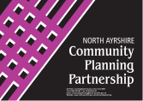 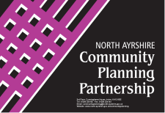

**This event is being held at Ayrshire College, Kilwinning Campus**

**Saturday 19 March 2016**

**12noon till 4.30pm (registration open from 11.30am)**

**Participatory Budgeting is a partnership and is funded by The Scottish Government,**

**The Ayrshire Community Trust and North Ayrshire Council**

For more information, to receive an application form & to reserve your place.

Tel: 01294 475900 or email: participatorybudgeting@north-ayrshire.gov.uk

**Deadline for applications is 9 March 2016, 5pm**

Come along for ~ Free Entertainment - Refreshments and Free Prize Draw!!

Voting for successful bids on the day is open to all ages 8+ who are resident in Kilwinning.

How would you like to spend **£12,000**?

Local people and groups can bid for up to **£700** to help make a difference with projects in the local area!

[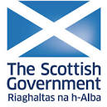](https://en.wikipedia.org/wiki/File:Scottish_Government_logo.png)

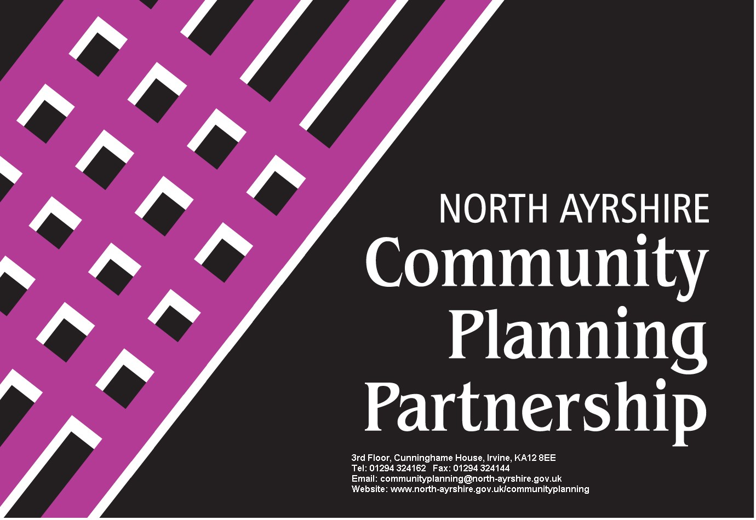

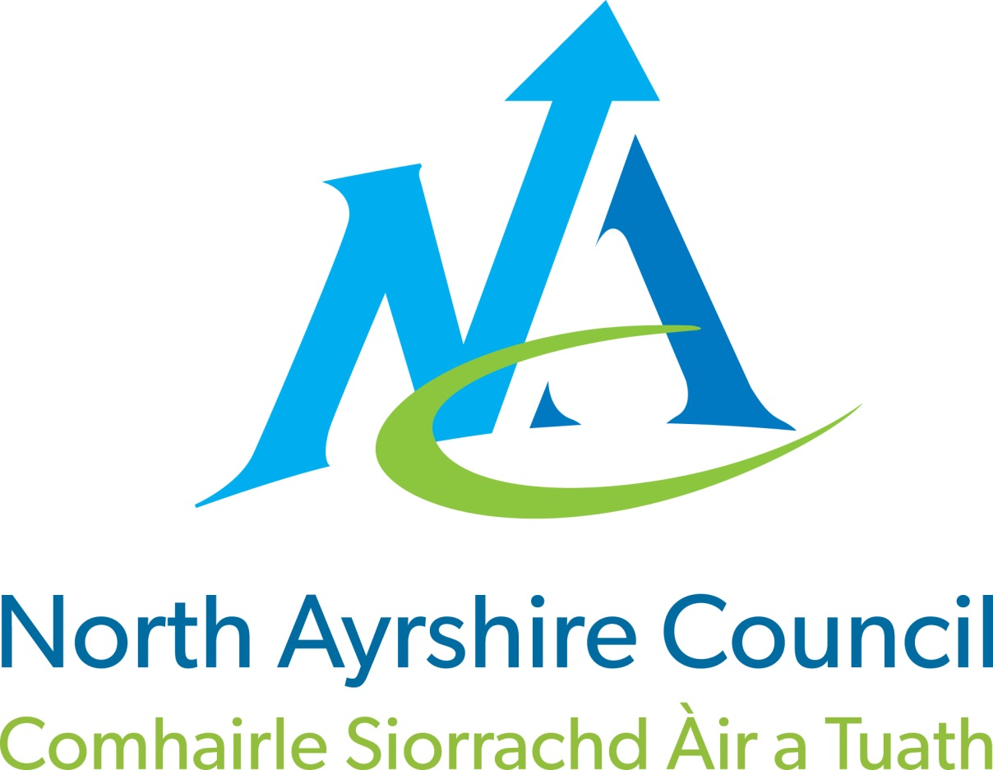

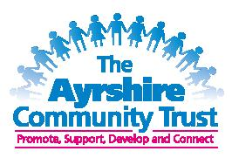

North Ayrshire Participatory Budgeting Pilot

**Kilwinning**

**£ Your Money, You Decide £**

